Special Relativity

Albert Einstein's theory of Special relativity (1905) is an explanation of how speed affects mass, time and space, it's the study of high speeds like the speed of light. The theory includes a way for the speed of light to define the relationship between energy and matter — small amounts of mass (m) can be interchangeable with enormous amounts of energy (E), as defined by the classic equation E = mc².

Special relativity applies to "special" cases — it's mostly used when discussing huge energies, ultra-fast speeds and astronomical distances, all without the complications of gravity, special in the sense that it depends on the perspective of an observer. Special relativity does not include curvature or what creates curvature which is gravity. Einstein officially added gravity to his theories in 1915, with the publication of his paper on general relativity.

SR is the study of high velocities, those close to the speed of light. The theory consists of two foundational postulates:
- the law of physics must be the same in all reference points, which are called inertial frames, others call this 'invariant' laws of physics. They are the same in all coordinates.
- The speed of light (in a vacuum) is constant in all inertial frames, the speed of light is the same in all coordinates and cannot be exceeded according to SR.

Inertial frames, which means an unchanging frame that is inert, is a reference frame, meaning a coordinate system in which motion and physical measurements of an observer are done. An inertial reference frame is simply a frame in which all objects are moving with constant velocity (v), like the speed of light (c), that is to say they are not accelerating. In SR a metric tensor is used, which is an object or a function that describes how distances are measured in a specific coordinate system, represented by matrices, also known as a Minkowski metric.

Lorentz Transformations
If we want to compare two different frames of references for two different observers, say Alice and Bob we use a transformation. Lorentz transformation is the relationship between two different coordinate frames that move at a constant velocity and are relative to each other. The name of the transformation comes from a Dutch physicist Hendrik Lorentz. To better understand how a Lorentz Transformation works let's take an example.

It's easy enough to describe motion itself – if something is moving relative to me,
that means it has different positions at different times, which I can plot on a spacetime diagram. This straight line corresponds to motion at a constant velocity of say, v units to the
right every second. And the question we're interested in is what do things look like from the moving perspective? Of course, the answer to this question is a physical one, and is determined by experimental evidence gathered by actually moving. And that evidence will come into play, but first we need to understand what it means, in terms of spacetime diagrams, to view something from a moving perspective.
We'll start with a key property of spacetime diagrams: when someone draws a spacetime diagram from their own perspective, on that diagram they're always, for all time, located at position x=0, since they're always a distance of 0 away from where they are, right diagram below. Or in other words: a spacetime diagram like this represents your perspective only if your worldline is a straight vertical line that passes through x=0.
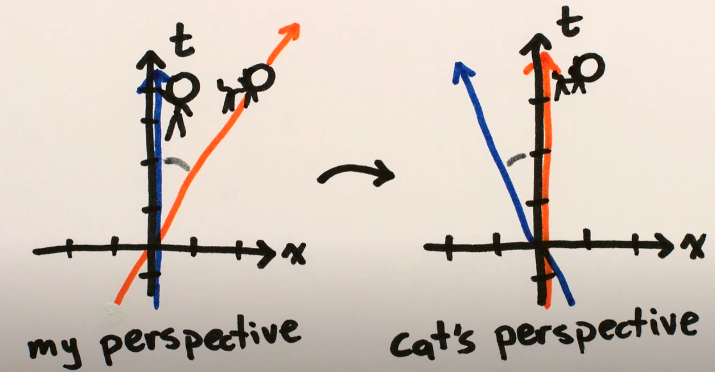

If, on a spacetime diagram, the worldline describing your motion leaves x=0 and goes
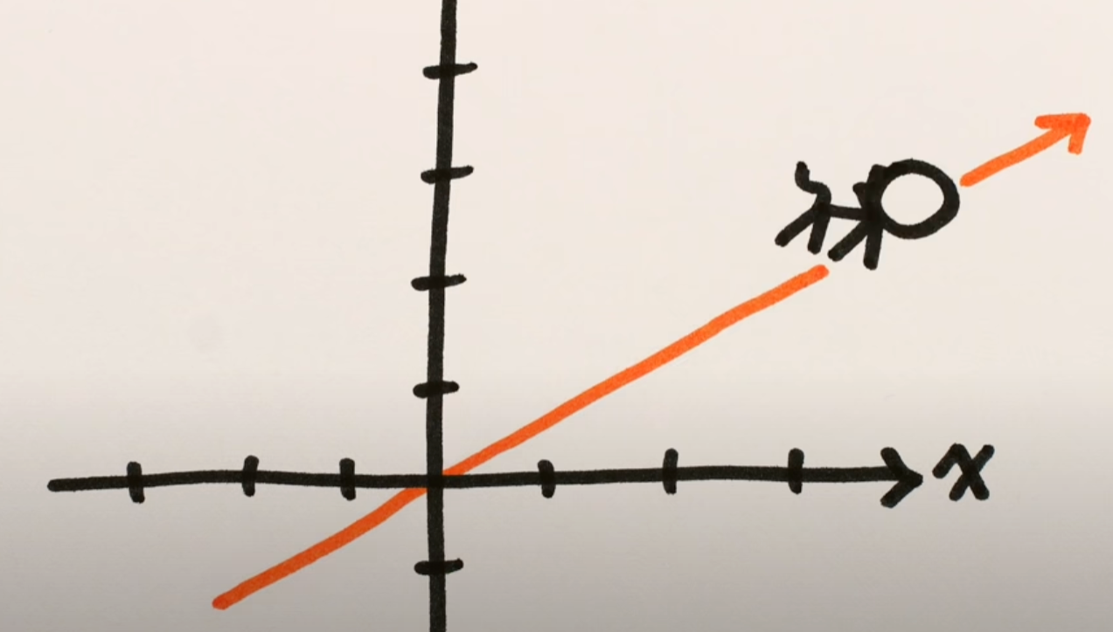
anywhere else, that means you're moving relative to the perspective of that particular diagram, and thus it's not your perspective. With this in mind, to describe how things look from the perspective of a moving object, like this cat, we simply need some way to transform spacetime diagrams that makes the worldline of the cat into a straight vertical line through x=0; or in other words, we want to make the spacetime diagram where the cat is moving into one where the cat's worldline coincides with the time axis.

That's not something we can do just by sliding the whole plot left or right or up or down,
like we've done for perspectives from different locations. No, changes of velocity require some sort of rotation to change the angle of the worldline, and importantly, whatever this rotation should be generalizable to a world line at pretty much any angle, since there was nothing special about the particular speed the cat happened to be going.
There are also two important pieces of experimental evidence that we'll need to take into account: first, if I measure the cat as moving at a speed v away from me, then the cat will measure me as moving at that same speed v away from it, and likewise if we're moving towards each other. Which means we not only want to transform the spacetime diagram in a way that the cat's angled line becomes vertical, but we also want the angle between our two lines to stay the same after the transformation – that is, from the cat's perspective, I should be
moving. The second piece of evidence we'll come to later. Let's focus just on the section of the cat's worldline from time t=0, where it's at x=0, to t=4, where it's at x=2. This section is a straight line between those two points, and we want it to end up as a straight vertical line, so we can simply leave the t=0,x=0 point unchanged while moving the t=4,x=2 point onto the time axis (where x=0). And there are really only three general possibilities for how to do this: either this point gets moved onto the time axis while keeping it at the same point in time, t=4, or it gets moved onto the time axis at an earlier time (say, t=3), or a later time (like t=5).

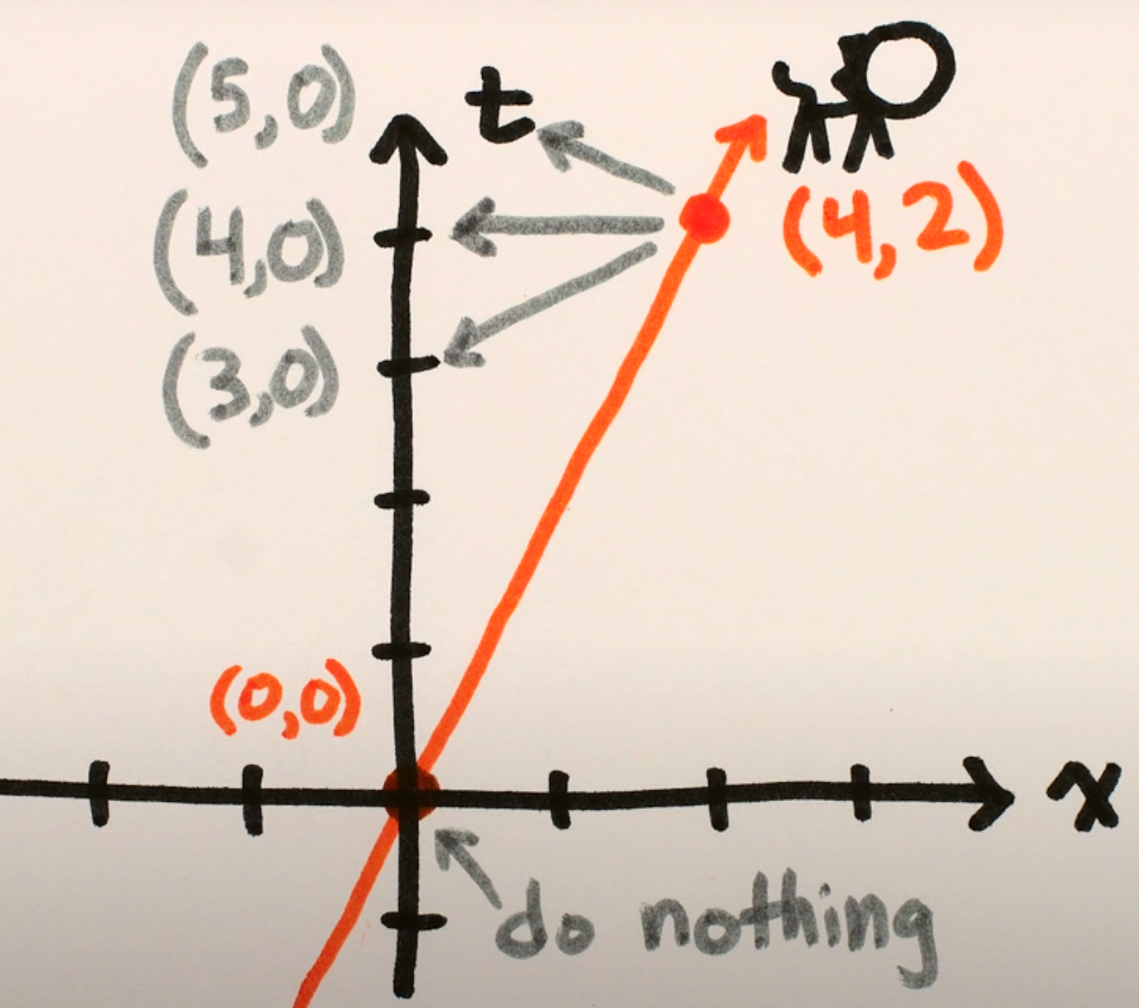
There's a very nice geometric way to picture these possibilities. If we think again of motion on a spacetime diagram as a series of snapshots, like, at time t=0 the cat is at position 0, at time t=1 the cat is at position 0.5, at time t=2 the cat is at position 1, etc, then the transformation where points move to the time axis and keep the same time just looks like sliding each snapshot over a corresponding amount; the possibility where points move to the time axis at a later time looks kind of like some sort of rotation around the origin; and the possibility where points move to the time axis at an earlier time looks kind of like some sort of squeezy rotation.
The reason these last two involve rotating the snapshots rather than just sliding is to make sure that the angle between the cat's worldline and my worldline stays the same
before and after the transformation Now, among these three, the option that makes the most intuitive sense based on our everyday experiences of the passage of time, is that a given point in time should stay at the same point in time, and just slide over to the time axis.
This is where the second and most famous piece of experimental evidence comes in: the speed of light.

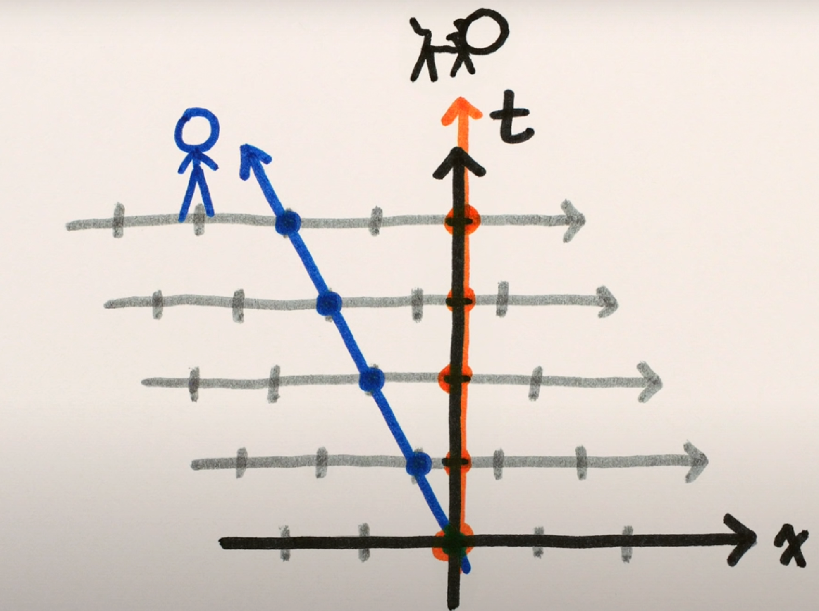

These squeeze rotation things are called Lorentz Transformations, named after one of
the first people to derive the correct mathematical expression for them – it looks kind of like
Lorentz Transformations are at the heart of special relativity – they're the thing that Lorentz and Einstein and Minkowski and others figured out was the correct description of how motion looks from moving perspectives in our universe, Now, as we've seen, Lorentz transformations look different depending on what speed you're trying to keep constant, or how you've scaled your axes. Normally, physicists draw their spacetime diagram tickmarks such that if every vertical tickmark represents one second, a horizontal tickmark represents 299,792,458 meters, which means that the speed of light, which is 299,792,458 meters per second, is drawn as a 45° line – to the right for right-moving light, and to the left for left-moving light. With this scaling, a Lorentz Transformation that leaves the speed of light constant simply consists of squeezing everything along one 45° line and stretching along the other in a particular, proportional way.
You can see immediately how this changes the angles of all of the other worldlines, that
is, changes how we perceive their speeds, and yet doesn't change any of the light rays.

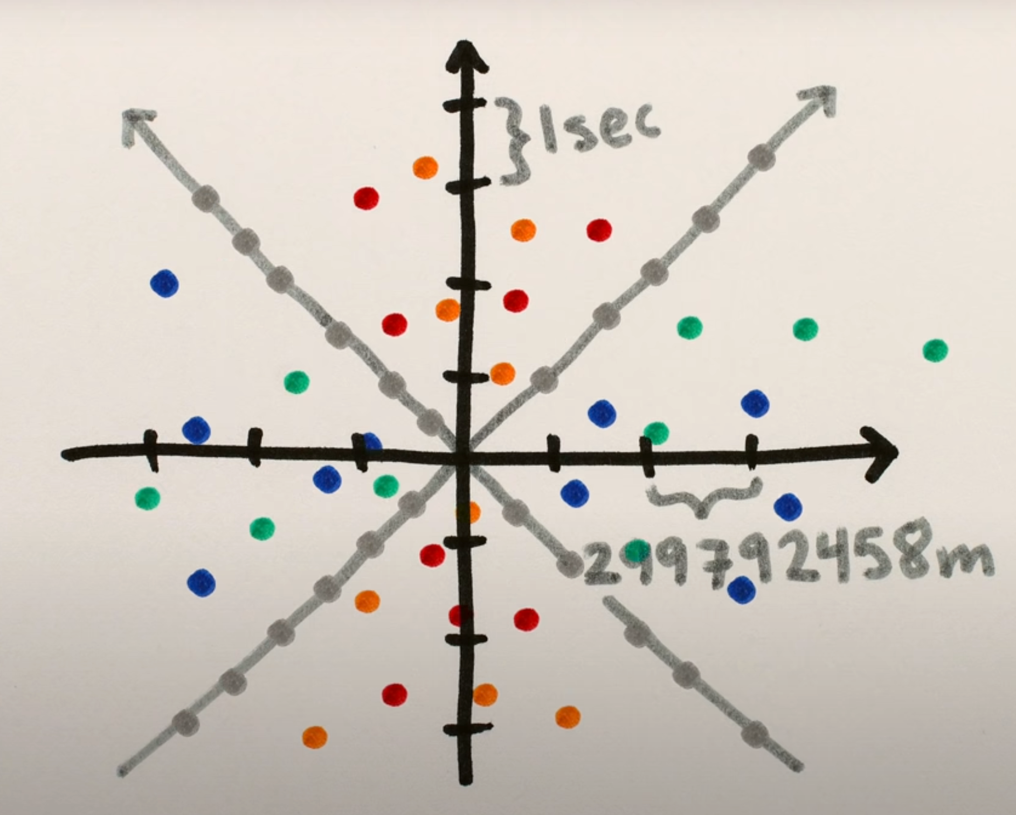 | 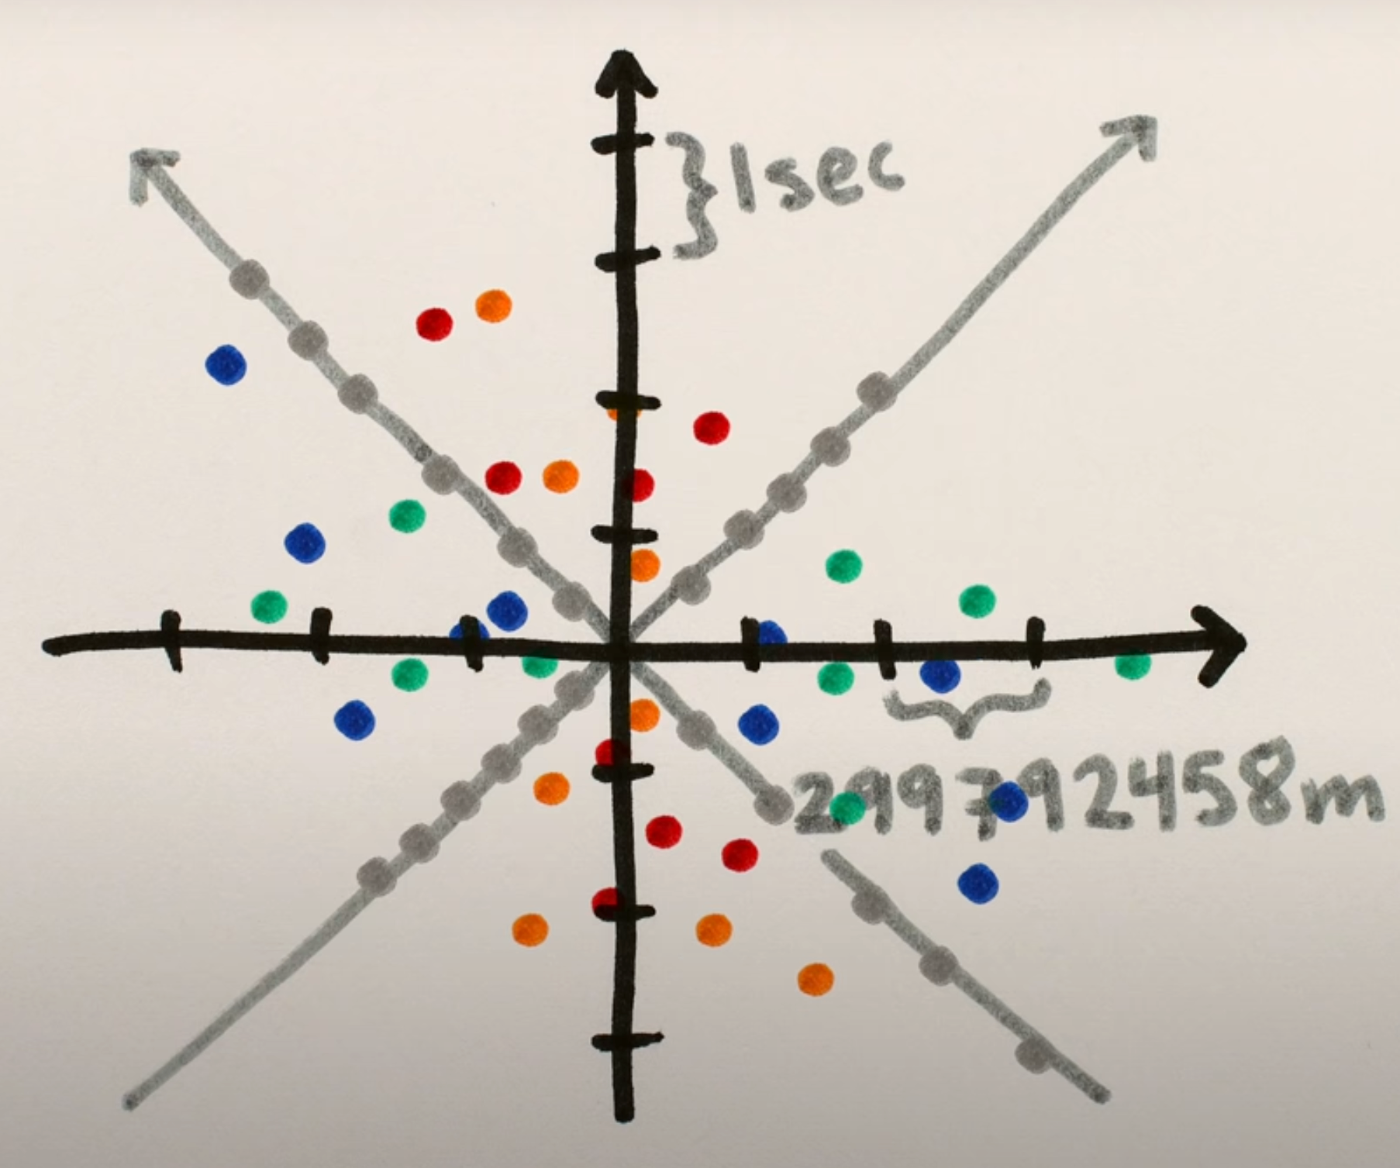 | 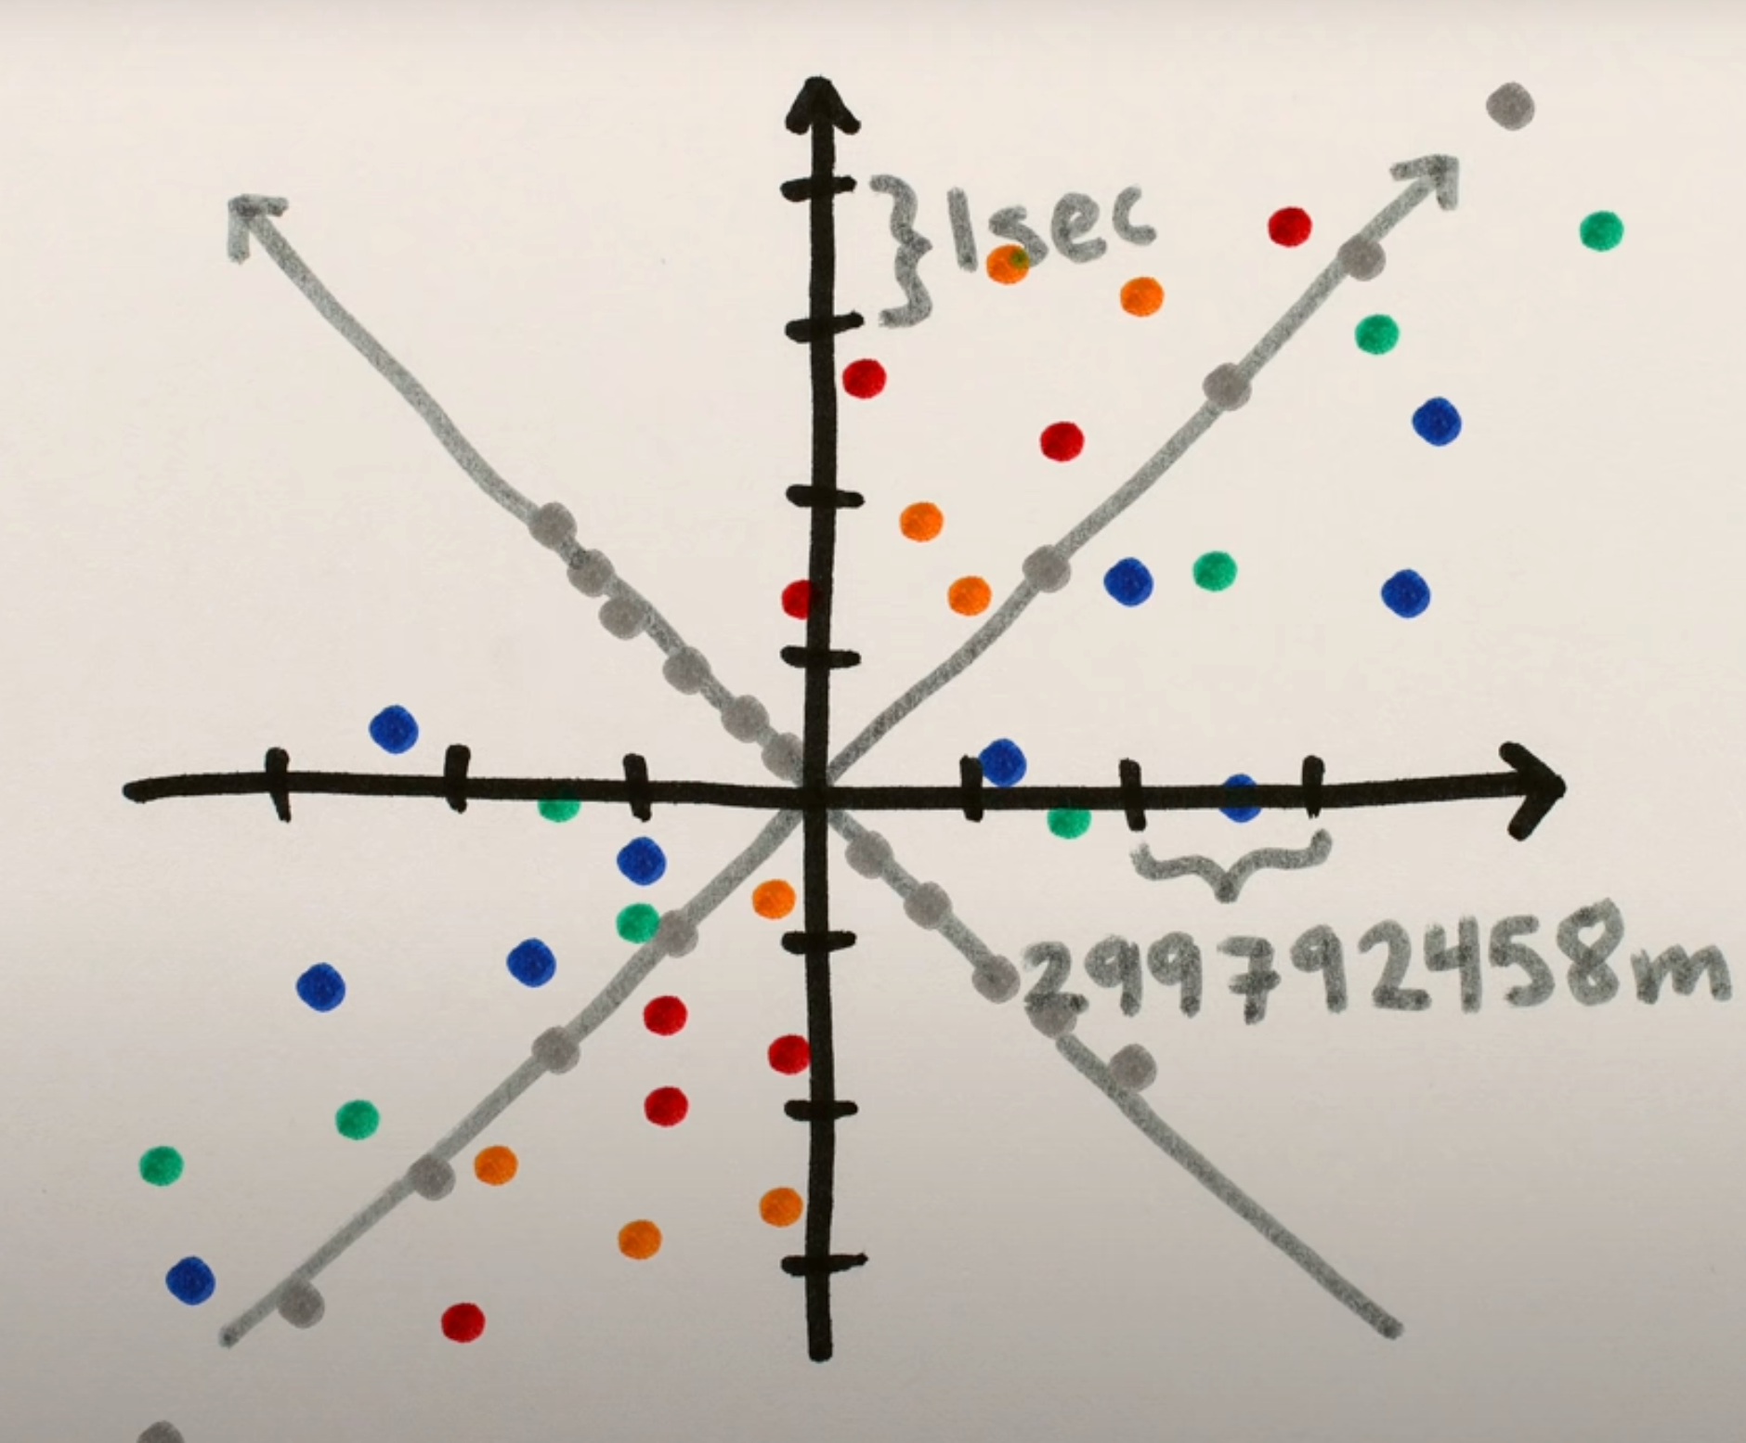

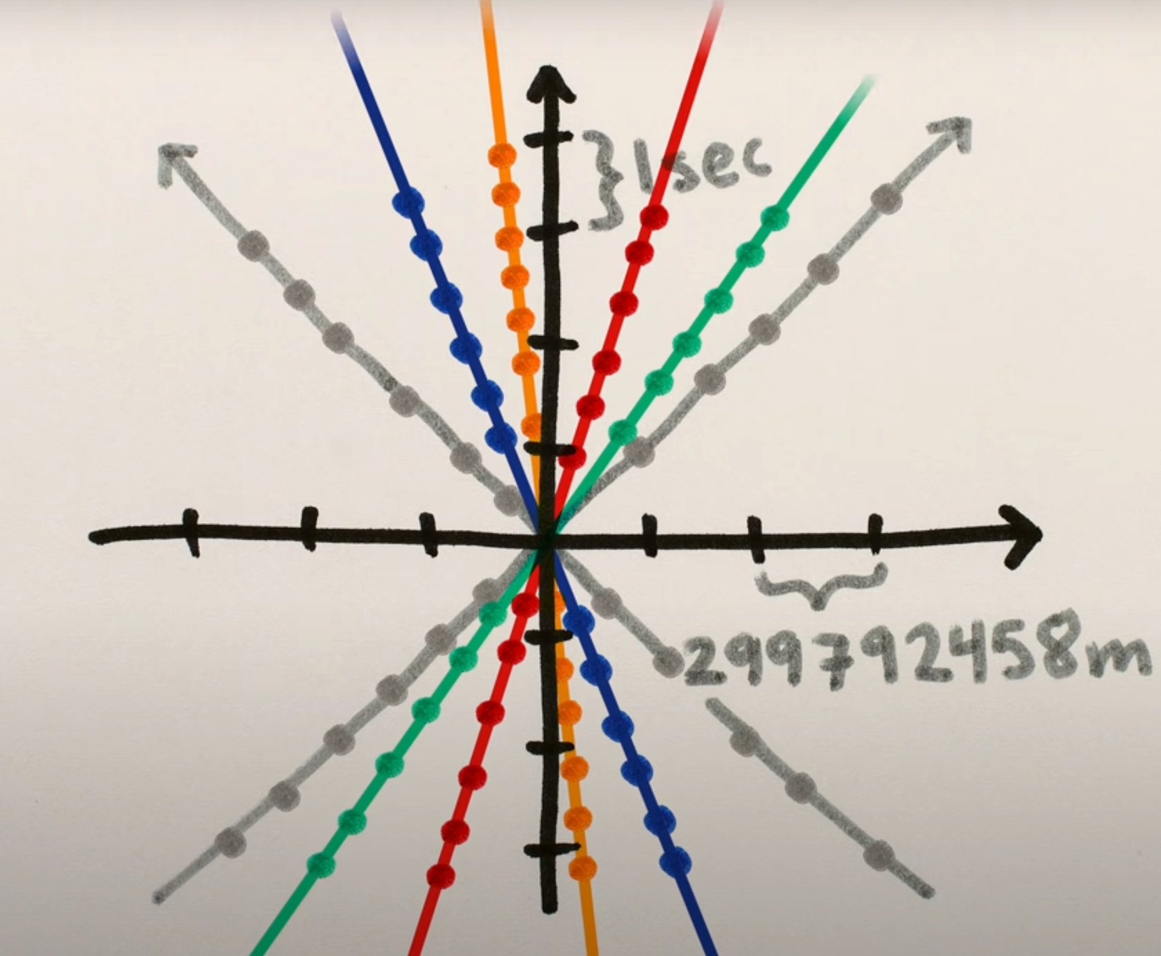 | 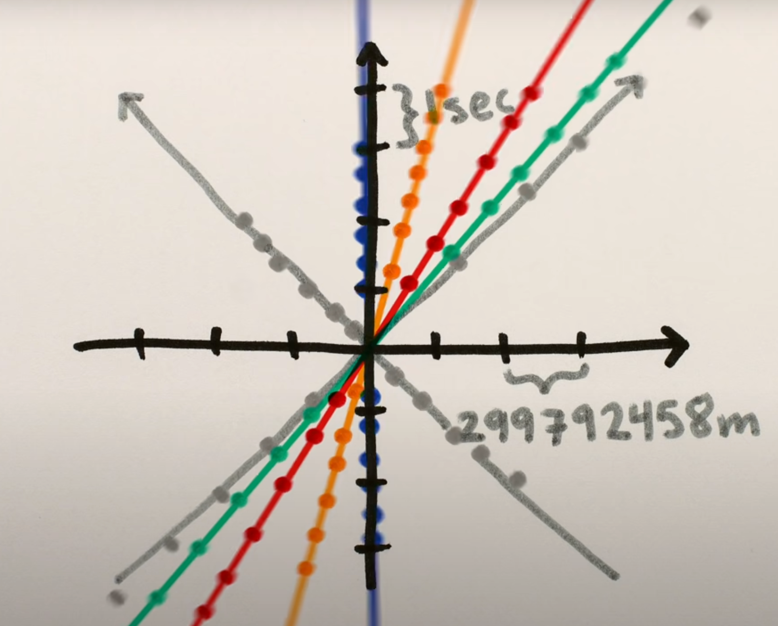 | 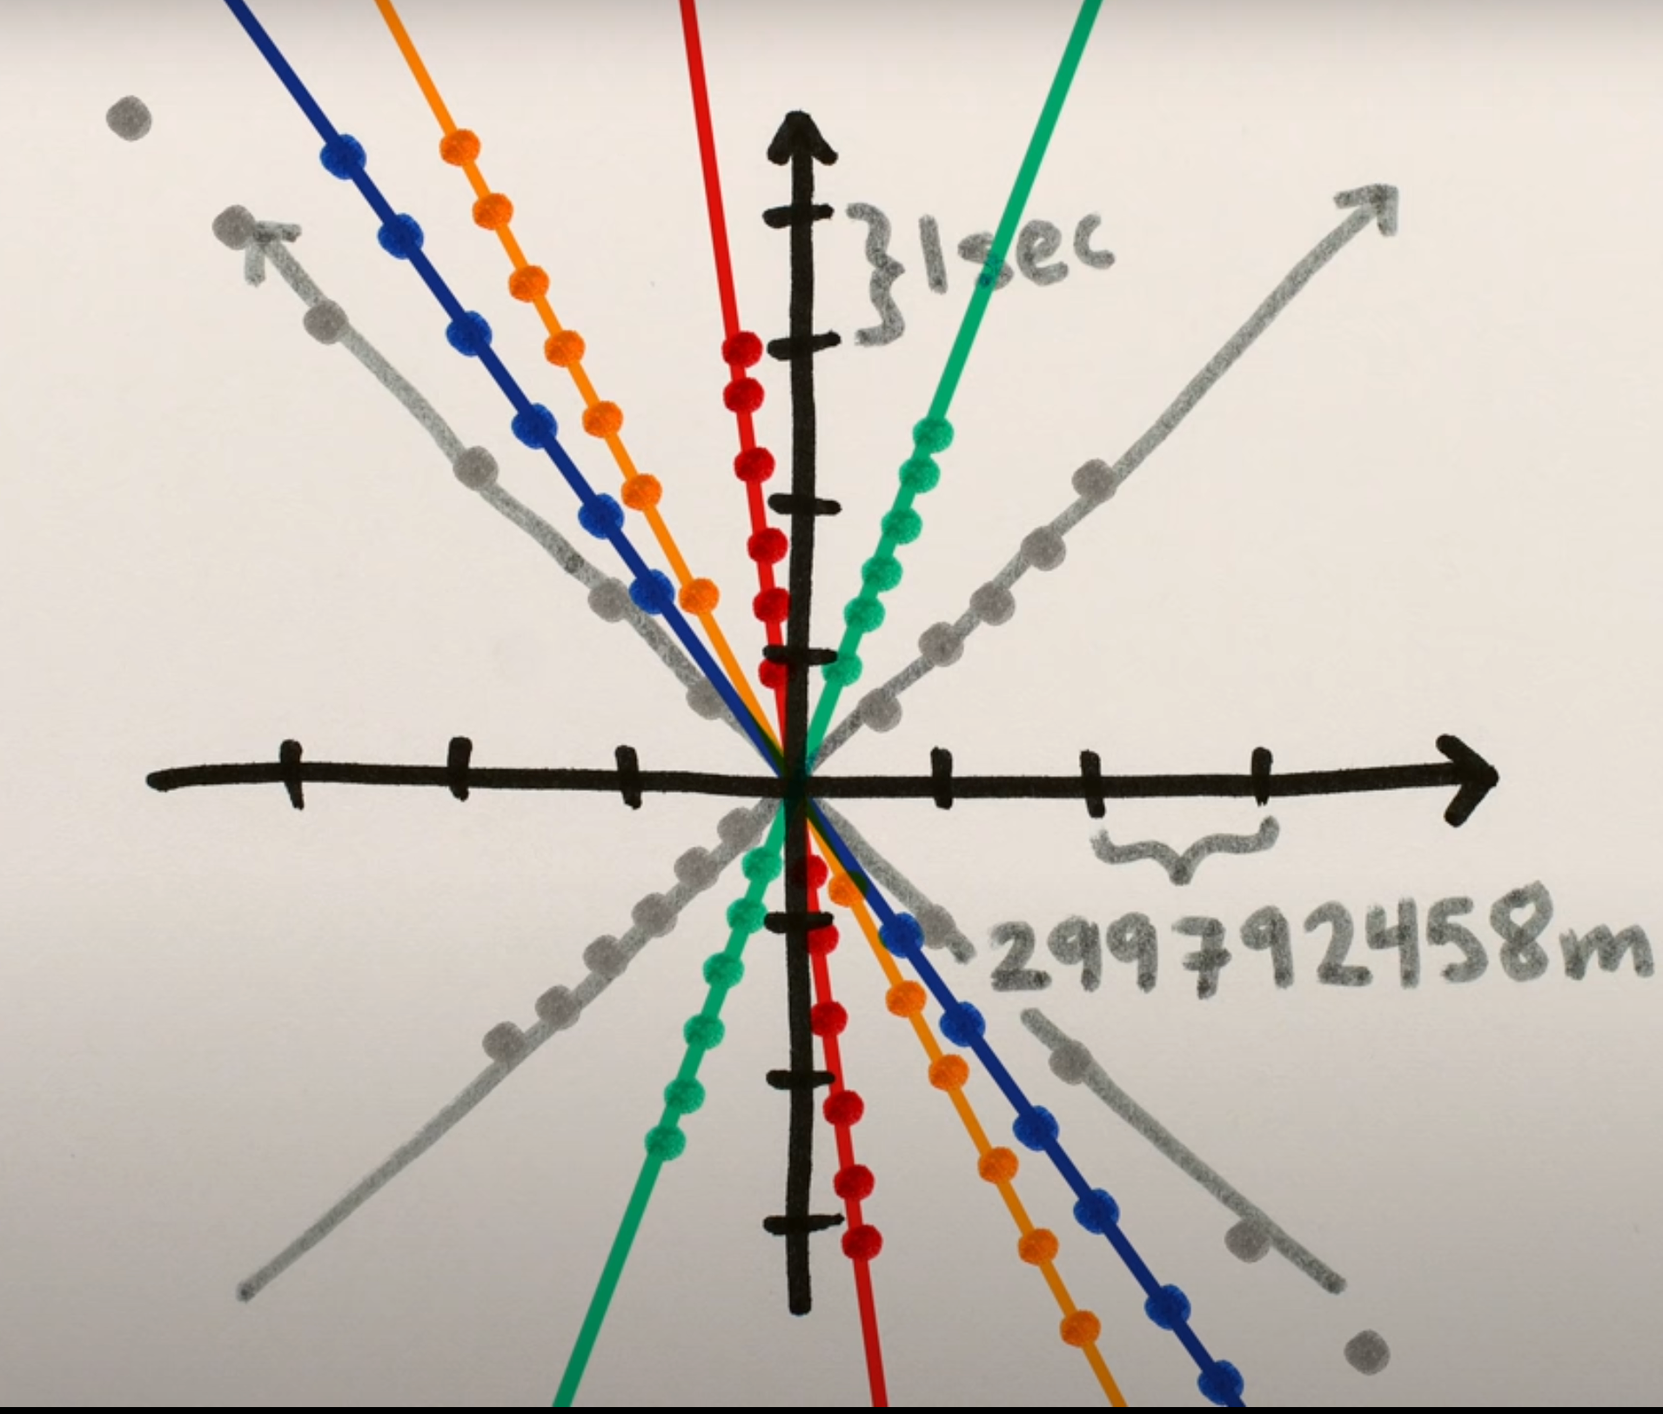

For more information and a visual representation of these concepts see: MinutePhysics (2018) Lorentz Transformations | Special Relativity Ch. 3, https://www.youtube.com/watch?v=Rh0pYtQG5w (accessed 6/18/22)

Other important topics in Special Relativity are those of time dilation, length contraction and relativity of simultaneity. These are best illustrated with an analogy of traveling on a train.
When time changes, that’s called time dilation, and when distance changes, that’s called length contraction. Time dilation occurs when another reference frame is moving relative to you, so time in that reference frame slows down relative to the time you measure.
Say Bob stands on the side of a train car that’s closer to the platform, your standing on the platform, the train is traveling in a vacuum at half the speed of light c/2. Bob is facing a mirror on the opposite side of the car, 5 meters away. He shines a flashlight toward this mirror, which reflects the light right back towards him. From Bob’s point of view on the train, the situation is very simple. The light traveled straight to the mirror and back, a distance of 10 meters, at the speed of light. Sure, looking through the window, you saw the light travel to the mirror and back, but meanwhile, the train was still moving.
While the light traveled toward the mirror, the mirror moved sideways relative to your spot on the platform. And while the light traveled back toward Bob, Bob moved even farther sideways. The result is that you saw the light travel diagonally, as though its path formed two sides of a triangle. From your point of view, the light traveled a greater distance than it did from Bob’s point of view. Special relativity tells us that the light’s speed was still exactly c.
Even though it traveled a greater distance. And if the light traveled a greater distance at the same speed then it must have been traveling for longer. You and Bob are both timing the exact same series of events. But you’re measuring a longer time than Bob is. So, from your perspective on the platform, time has slowed down for Bob. That’s time dilation.
If you measured the distance the light was traveling from your perspective on the platform,
you’d calculate that time slowed down for Bob by a factor of 1 divided by the square root of 1 minus the train’s velocity squared divided by the speed of light squared.
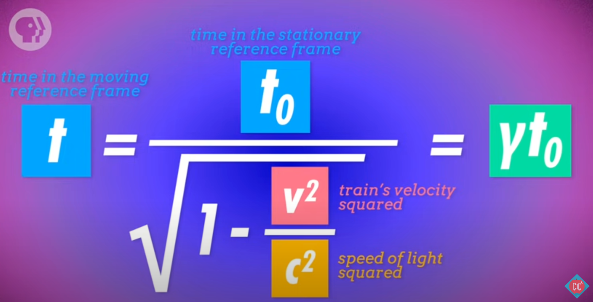

We call this factor gamma, and it applies to any situation where another inertial reference frame is moving relative to yours. Time in that moving reference frame will seem to equal time in your reference frame, multiplied by gamma (γ). Gamma always has to be greater than 1, because the velocity of the moving reference frame always has to be less than c, the speed of light. So time is slower in that moving reference frame. Because time can pass differently for people depending on their frame of reference, there’s also no universal concept of simultaneity. In other words, something that seems simultaneous to you might not be simultaneous to Bob.
As if time slowing down wasn’t weird enough, there’s also length contraction.
Length contraction means that if something is moving relative to you, its length in the direction that it’s moving will seem shorter than it would if it wasn’t moving. So you might have measured the train to be 100 meters long before it left the station. If Bob measures the train from where he’s standing, it will be 100 meters long. But from your perspective on the platform as it moves past you, the train will be shorter. Let’s say you want to measure the train as it moves past the spot where you’re standing on the platform. The train is moving at half the speed of light. That’s set. From Bob’s perspective, it takes about 6.66 x 10⁻⁷ for the train to pass you. Velocity multiplied by time equals distance, so Bob calculates that the train must be 100 meters long. Now you try taking the same measurement. Problem is, we already know that time moves faster for you than for Bob. While 666 nanoseconds pass for Bob, only 577 nanoseconds pass for you. And if the train takes 577 nanoseconds to pass you while it’s moving at half the speed of light, it must be 86.6 meters long!
In general, when something’s moving past you, its length in the direction of its motion will be equal to the length you’d measure if it was standing still, divided by gamma. So special relativity tells us that because light always travels at the same speed, time dilates and length contracts to compensate. For more information and a visual representation of this analogy see Crashcourse in Physics (2017) Special Relativity: Crash Course Physics #42, https://www.youtube.com/watch?v=AInCqm5nCzw (accessed 6/19/22)

